

Lab Policy and Rules:

1. 100% attendance is mandatory. In case of an emergency, you can avail yourself of up to 3 absences. So, don't waste your absences , save them for emergencies. If you are debarred from the course due to low attendance, do not come to me to correct it.

2. Disturbing the class environment during lab sessions. such as by talking, using mobile phones, eating, etc. will result in penalties (e.g., deduction of marks).

3. Lab tasks will not be accepted if you are absent. If you miss a lab, you cannot submit that lab task.

4. Lab demos for each lab task will be conducted at the end of each session. If you miss the demo for any reason, no retake will be allowed, and that lab will be marked as 0.

5. All quizzes will be unannounced. Be prepared for surprise quizzes. Quizzes will cover content from previous labs as well as theory lectures from the corresponding theory course.

6. Use of AI is strictly prohibited, anyone found using AI or copying code from fellow student will be marked 0 in the lab task . You should be able to explain the syntax or material used in your tasks.

7. Do not ask for personal favors. If you have concerns, such as short attendance, please speak to the relevant authority (e.g., academics).

8. Students on warning: Now is the time to study and earn a good grade. Do not ask for extra marks at the end if you are unable to clear your warning.

Lab#04 – Linked List

Learning Objectives:
- Understand the Concept of Linked Lists: Develop a clear understanding of the structure, working, and types of linked lists (singly, doubly, circular).
- Implement Linked List Operations Using C++: Gain practical experience in implementing insertion, deletion, traversal, and searching operations on a linked list.
- Develop Problem-Solving and Debugging Skills: Enhance analytical and programming skills by applying algorithmic thinking to manage dynamic data structures.

Outcomes:
- Apply the concepts of dynamic memory allocation and pointer manipulation to create and manage linked lists.
- Implement efficient linked list operations such as insertion, deletion, searching, and traversal using C++.
- Analyze the performance of linked list operations in terms of time and space complexity and select appropriate techniques for problem-solving.

Linked list Data Structure
A linked list is a linear data structure that includes a series of connected nodes (not in consecutive memory locations like array). Here, each node stores the data and the address of the next node. For example,

You have to start somewhere, so we give the address of the first node a special name called HEAD. Also, the last node in the linked list can be identified because its next portion points to NULL.
Linked lists can be of multiple types: singly, doubly, and circular linked list. Today we will focus on the singly linked list.

What is a Linked List
linked lists are linear data structures, meaning there is a sequence and an order to how they are constructed and traversed. In order to get to the end of the list, we have to go through all of the items in the list in order, or sequentially. Linear structures, however, are the opposite of non-linear structures. In non-linear data structures, items don’t have to be arranged in order, which means that we could traverse the data structure non-sequentially.
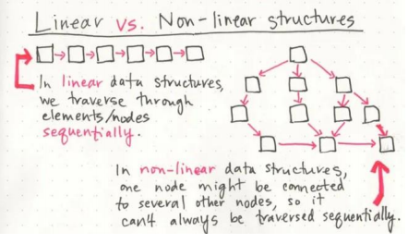

How is a Linked List different from an Array?
The biggest differentiator between arrays and linked lists is the way that they use memory in our machines. When an array is created, it needs a certain amount of memory. If we had 7 letters that we needed to store in an array, we would need 7 bytes of memory to represent that array. But we’d need all of that memory in one contiguous block. That is to say, our computer would need to locate 7 bytes of memory that was free, one byte next to the another, all together, in one place.
On the other hand, when a linked list is created, it doesn’t need 7 bytes of memory all in one place. One byte could live somewhere, while the next byte could be stored in another place in memory altogether! Linked lists don’t need to take up a single block of memory; instead, the memory that they use can be scattered throughout.
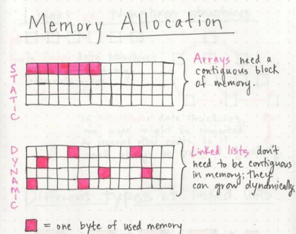

Parts of a Linked List:
A linked list is made up of a series of nodes, which are the elements of the list. The starting point of the list is a reference to the first node, which is referred to as the head. Nearly all linked lists must have a head, because this is effectively the only entry point to the list and all of its elements, and without it, you wouldn’t know where to start! The end of the list isn’t a node, but rather a node that points to null, or an empty value.
A single node is also pretty simple. It has just two parts: data, or the information that the node contains, and a reference to the next node.
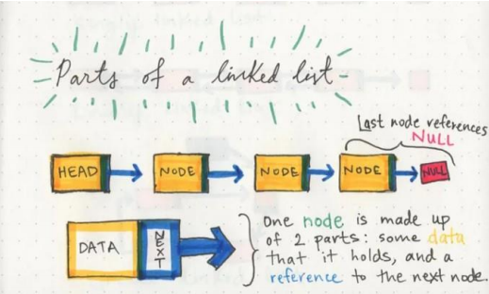

Creating a node class:
This C++ code defines a class called Node, which is commonly used to create nodes in a singly linked list.
The class consists of two data members.
- The variable val will store the data (or value) associated with the node.
- Node *next;: Declares a pointer member variable named next within the Node class. This pointer is used to point to the next node in the linked list. Initially, it is set to NULL to indicate that there is no next node.
Node(int val): Defines a constructor for the Node class. This constructor takes an integer val as a parameter and initializes the val member variable with the value passed as an argument. It also sets the next pointer to NULL.
So, this Node class is used to create individual nodes for a singly linked list, where each node contains an integer value (val) and a pointer to the next node (next).
Sample Code:
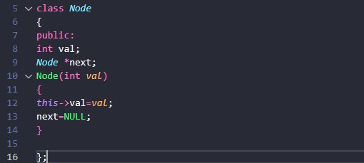

Creating the LinkedList class:
class LinkedList: Defines a class named LinkedList to represent a singly linked list. It has also two data members.
- int length: This variable will store the current length or number of nodes in the linked list.
- Node* head: Declares a pointer member variable named head within the LinkedList class. This pointer is used to point to the first node in the linked list. Initially, it is set to NULL to indicate that the list is empty.
LinkedList (): Defines a constructor for the LinkedList class. This constructor is responsible for initializing the linked list.
length=0;: Initializes the length member variable to zero, indicating that the list is initially empty.
head=NULL;: Initializes the head pointer to NULL, indicating an empty list with no nodes.
So, this LinkedList class provides a basic structure for managing a singly linked list. It keeps track of the list's length and maintains a pointer to the first node (head) in the list.
Sample Code:
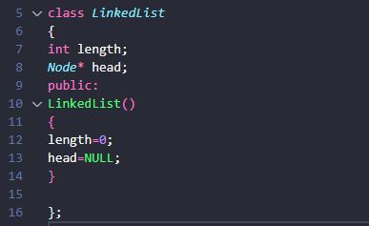

Check if the list is empty:
In case the list is empty the head node always points to NULL, which is initialized in the constructor of the LinkedList class.
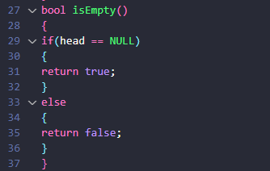

Insertion in the List:
The insert function in the LinkedList class is designed to insert a new node with a given value at a specified position within the linked list. It begins by checking if the position provided (pos) is valid, which means it must be within the range of 1 to (length+1), where "length" represents the current number of nodes in the list. If the position is invalid, it prints an error message and exits. If the position is 1, indicating insertion at the beginning of the list, it creates a new node (temp) with the given value and makes it the new head of the list by updating the head pointer and setting its "next" pointer to the previous head. For positions other than 1, it iterates through the list to find the node immediately before the desired position (pos-1) and inserts the new node (temp) between this node and the next node, by connecting through pointers. Finally, it increments the length variable to reflect the addition of the new node.
Sample Code:
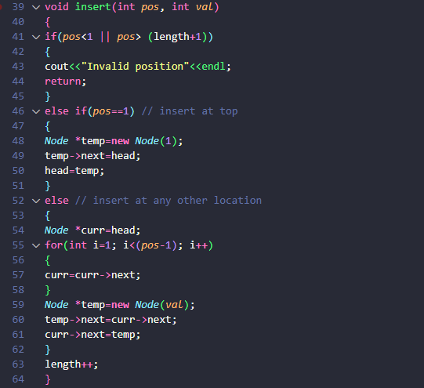

Printing the List
The printList function in the LinkedList class is responsible for traversing the linked list and printing the values of each node.
This function starts by creating a temporary pointer curr and initializing it to point to the head of the linked list. It then enters a while loop, which continues as long as it reached the end of the list, which we can identify when the curr becomes NULL. Inside the loop, it prints the value (val) of the current node pointed to by curr. After printing the value, it updates curr to point to the next node in the list (curr->next) to continue traversing the list. This process repeats until curr becomes NULL, meaning it has reached the end of the list.
Sample Code:
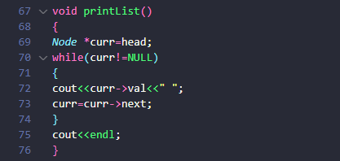

Searching in the List:
This function starts by initializing a boolean variable found to false, indicating that the element hasn't been found yet. It then creates a temporary pointer curr and initializes it to point to the head of the linked list. Next, it enters a while loop, which continues as long as curr is not NULL. Inside the loop, it checks if the value (val) of the current node pointed to by curr is equal to the value being searched for. If a match is found (i.e., curr->val equals val), it prints "Element found" to indicate that the desired value was found in the list and sets found to true to record the finding. The loop continues, allowing the function to search the entire list. After exiting the loop, it checks the found variable; if it's still false, it means the element was not found in any of the nodes, so it prints "Element not found" to indicate that the value was not present in the list.
Sample Code:
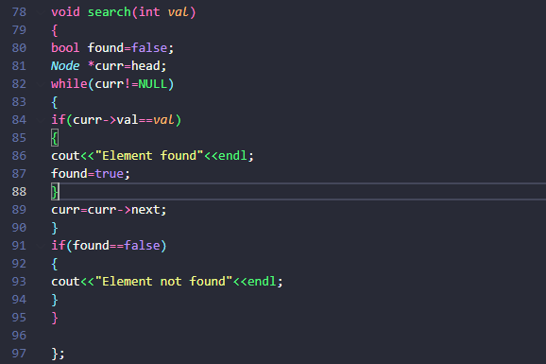

Main Code:
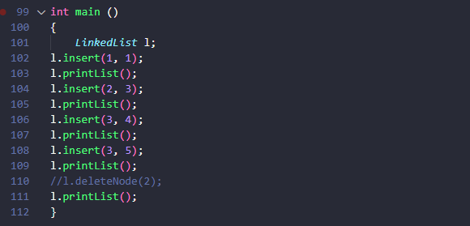

Sample Output:
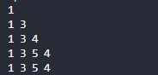
Note that the delete, and update methods should be implemented on your own.

Lab Tasks

Task 01:
Implement the following functions for linked list:
  - Insert front
  - Insert End
  - Insert after number
  - List is full
  - List is empty
  - Display all element
  - Sort the list
  - Limit user so that he/she can only add 10 numbers in the list. After that give error that list is full.
  - Delete a specific node entered by user

Task 02:
The university is developing a system to analyze the sequence of courses that a student must complete before being allowed to enroll in an advanced course.

Each course may have one or more prerequisite courses. However, for the current semester, the university has simplified the prerequisite structure so that each course points to the next course that should normally be completed.

For example, consider the following academic path:

Programming Fundamentals
↓
Object Oriented Programming
↓
Data Structures
↓
Algorithms
↓
Advanced Algorithms

The department wants a program that can analyze this course sequence.

Instead of storing the sequence in an array, the sequence must be represented using a singly linked list, where each node represents a course and its next pointer represents the next course in the recommended academic path.

However, the system is not simply required to display the courses.

The interesting part is that students may have already completed some courses, and the system must determine what they are currently eligible to study.

Course Information

Each course contains:

Course Code
Course Name
Credit Hours
Completion Status

For example:

CS101 Programming Fundamentals 3 Completed
CS201 OOP 3 Completed
CS301 Data Structures 3 Not Completed
CS302 Algorithms 3 Not Completed
CS401 Advanced Algorithms 3 Not Completed
System Logic

The courses are stored in a linked list representing the recommended sequence.

A student is considered eligible for a course only if all courses before it in the sequence have been completed.

For example:

CS101 → CS201 → CS301 → CS302 → CS401

If:

CS101 = Completed
CS201 = Completed
CS301 = Not Completed
CS302 = Not Completed
CS401 = Not Completed

then the student is currently eligible for:

CS301

The student cannot directly take CS302 or CS401, even though they appear later in the list.

The Complication

The administration wants to simulate different student situations.

The user should be able to mark a course as completed.

Whenever a course is completed, the system should determine the next course for which the student has become eligible.

For example:

CS101 → CS201 → CS301 → CS302 → CS401

Initially:

CS101 = Completed
CS201 = Completed
CS301 = Not Completed
CS302 = Not Completed
CS401 = Not Completed

The program reports:

Currently Eligible:
CS301 - Data Structures

After the student completes CS301:

CS101 = Completed
CS201 = Completed
CS301 = Completed
CS302 = Not Completed
CS401 = Not Completed

The program should now report:

CS302 - Algorithms

After CS302 is completed:

CS401 - Advanced Algorithms

becomes eligible.

Required Features

Your program should provide the following functionality.

1. Create Academic Path

The user should enter the courses that form the recommended academic sequence.

The program should create the sequence dynamically using a singly linked list.

2. Mark Course as Completed

The user enters a course code.

The program should search the linked list and change its completion status.

If the course does not exist, display an appropriate message.

If the course has already been completed, inform the user.

3. Find Current Eligible Course

The program should analyze the entire linked list and determine the first course that has not been completed after a continuous sequence of completed courses.

For example:

CS101 ✓ → CS201 ✓ → CS301 ✗ → CS302 ✗ → CS401 ✗

Output:

You are currently eligible for:
CS301 - Data Structures
4. Check Graduation Progress

The university wants to know how far the student has progressed through the academic path.

Display:

Courses Completed: 3
Courses Remaining: 2
Progress: 60%

The percentage should be calculated by your program rather than entered by the user.

5. Display Academic Path

Display the complete path and status:

CS101 → Programming Fundamentals ✓
CS201 → Object Oriented Programming ✓
CS301 → Data Structures ✓
CS302 → Algorithms ✗
CS401 → Advanced Algorithms ✗
6. Find Whether Student Can Graduate

The student can graduate from this particular academic path only when all courses have been completed.

The program should determine this automatically.

For example:

All courses have been completed.
Student has completed the academic path.

or:

Student cannot complete the academic path yet.
Courses remaining: 2
Menu
=========================================
COURSE PATH ANALYZER
=========================================

1. Create Academic Path
2. Mark Course as Completed
3. Find Current Eligible Course
4. Show Academic Progress
5. Display Complete Course Path
6. Check Graduation Status
7. Exit

Enter your choice:

Task Submission Guidelines:
- Make a document and paste all tasks solution there (Not screenshot) and save it as pdf.
- Along with each task solution, also upload the screenshot of the output.
- Include your name and roll no. at the front page.
- Please submit your file in this format (Roll_number-name) i.e (24I-1234-Ali.pdf).
- Files other than pdf will not be accepted and will be marked as 0.

